Worklog summary week 6

Angelo Anthony Rettob  
181494, IGAD Programmer

Table of Contents

**Monday** **3**

Adding projectiles 4

**Tuesday** **5**

**Wednesday** **6**

**Thursday** **7**

Implement AI decision making 7

**Friday** **9**

# Monday

I’m about to implement entity stats. These are the stats entities have according to the wiki.

* Starting power
* Armor Strength
* Shot Strength
* Magic Strength
* Fighting ability
* Player Speed

I will use these stats as a reference, but they are from a different version.

Important is how I use these stats. I’m thinking of having a base entity class that has these values because else I’ll be copy-pasting these in both player and enemy.

I will be using the [Command Pattern](http://gameprogrammingpatterns.com/command.html) to define the logic behind the entities. So I will need to expose the variables. I will probably be using virtual getters because Abhishek told me so and the stats are constant amongst all entities. Okay, that’s not the best reasoning. The real reason why these getters will be virtual is that the hero class needs to overwrite these values. When a hero picks up a potion, the stats will be increased.

The player has an inventory. I will return the value + the count that a potion is in the inventory.

There is one thing that I did overlook. How will I change monster stats depending on their level? I don’t think constant stat values is the way to go. I will also try to use another pattern. It is called the [Type Object](http://gameprogrammingpatterns.com/type-object.html). The reason why I will use this is that I don’t have to make all kinds of classes for my entities. All entities differ in are stats and texture. Only some entities differ in behavior. The lobber and thief. But we can fix this with the command pattern.

A combination of type object and command pattern will make sure to keep my code down to a minimal. I really dislike making many many classes because it increases compile time and most of the time they don’t really differ from each other. Right now though, I’m not really using OOP because I’m running switched inside my monster class, but that will change pretty soon.

After a while, the whole solution seemed a bit wrong. I have to keep track of leveling the skills. But also changing some of the stats. For example, the player's health drains over time. I need to change that stat every few seconds. The monster's stats depend on their level, but the player stats depend on their potion. A base entity class with setter functions will be my way to go. I will define the getters for enemies and players thus entity will become an

interface class.

## Adding projectiles

To first add projectiles, we have to move the logic from the player into classes. Using the command pattern.

Projectiles will get their own vector in the map. This is because projectiles are also rendered off-screen. They do not occupy an element in the map.

# 

# Tuesday

Making player shoot.

# 

# Wednesday

Look up constexpr keyword

# 

# Thursday

Observing the SOLID principles was quite interesting. I still find the principles to be quite vague but I do understand why they exist. Many of the problems noted in the SOLID principles are represented in my project.

* My objects don’t follow the Liskov substitution principle.
* The virtual update functions abuse the single responsibility principle.

## Implement AI decision making

Observing the decisions of the monsters shows the following behaviors:

* Ghosts and grunts walk to the player, always.
* Demon also always walks to the player but also shoots a fireball if the player is along an axis and no object is next to him.
* The Lobber attacks the player but when the player comes near he moves away in the opposite direction to the player.
* The last we have is the thief. He rushes to the player and knows how to walk around corners. I haven’t seen what happens when he touches the player though. He probably steals something.

So we have monsters with no conditions, three conditions and two conditions. How are we gonna implement this?

Before starting this I have read many articles on the SOLID-C principle. These are my sources. [LINK](https://www.tomdalling.com/blog/category/software-design/) [LINK](https://www.gamedev.net/blogs/entry/2265481-oop-is-dead-long-live-oop/).

We already have the SDP because a monster is only responsible for the collection of commands. The problem is that different monsters react differently depending on the monster type. We should use a monster as an interface and define three new types. This way, we can easily implement new AI behaviors.

So this is how it should work:

* It is **SRP** because the monster class is responsible for the behavior that triggers the commands.
* It is **OCP** because we won’t be modifying the parent class. We only extend the derived classes.
* It is **LSP** because we access all these derived monsters by the interface and we do not need any kind of casting. (Do note that I do use an update function, but it is too late to change that right now).
* It is **ISP** because it’s an interface for only one thing, the behavior of AI triggers/decision making.
* It **isn’t** **DIP** because it uses the implementation of the base object class. This class is already getting bloated with flags in an attempt to keep is LSP.
* It isn’t **CRP** but kinda is because the behavior is defined inside independent classes which are **ISP** because they don’t have access to anything of the class. But it isn’t **CRP** because the object class exposes many unnecessary variables.

I’m never gonna write something like that again, but I do have a good idea about my implementation now.

# 

# Friday

Moved entities to a different folder.

I’m having trouble with deciding how to implement different kinds of AI logic. Initially, I wanted to implement different kinds of monsters. Monsters like MeleeMonster, ShootingMonster, FastMonster. This was to avoid code duplication for monsters like demons and wizards, grunts and ghosts. But there is only one kind of lobber. So instead of making monster classes, I decided to make monster AI types.

To support different AI for different monsters. I will be making finite state machines. I will pass these to the monsters. This way, we won’t be needing any monster classes, because their data is defined inside the MonsterSpawn file.

**12:25 Monsters too fast**

The movement had a weird bug. Objects kept teleporting. This happened after I tried to optimize the game because the performance issues were huge.



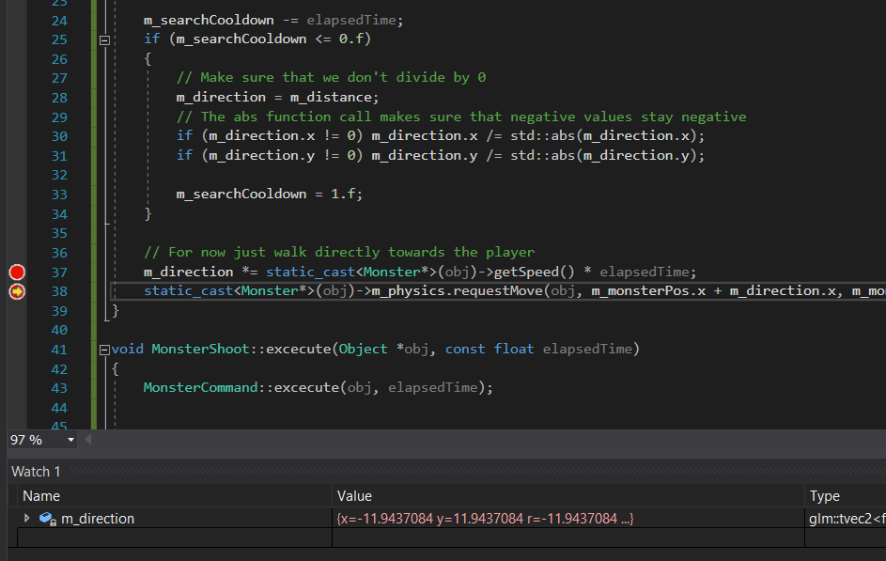

This was because the direction value keeps increased every frame. Previously, this value would be reset because it recalculates the path it has to take, but this had major performance issues. (I went from 150 fps to 15). So it only calculates it path every second now.

**12:35 Fixing the collision resolving**

Objects tend to despawn during movement. This is because of the way collision are managed in the handler. The physics manager will overwrite a spot in the grid whenever the objects move.



While ghosts are supposed to disappear, this is not intended behavior. I really have to get this fixed before I’m moving on with my project.

**15:00 Found the collision resolve problem**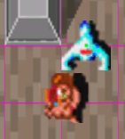

I’ve marked the origin with green and cells with purple. You can see that both objects try to occupy the same cell. They are not colliding though, so the physics engine allows this.

I have two ways to fix this. I can make it so that the physics engine will not allow the movement to replace the object. By doing this the object will collide in the system but not on screen. By using this system the map grid will still be used which is handy for collisions.

I can also move all moving objects to another vector. This will decouple the physics engine from the map class. Objects will not make use of the grid system though and checking for collisions will become around 18 * 10 / 9 times more expensive (which is about 20 times).

I’m probably going for the last solution. It doesn’t sacrifice on the gameplay and right now the physics engine takes about 0% CPU time. I don’t expect this to be a bottleneck.

I also have to consider that only objects on the screen are updated. I will need an additional check in the update loop of the map because of this.